Driscoll – The King of Berry Mountain

Remarks by: Chuck Benbrook
Real Organic Project 2026 Annual Meeting
Churchdown Dairy Hudson, NY September 19, 2026

Berries are a vitally important slice of the food pie if progress is to be made in making America healthy again. I love berries and try to eat at least a half pint daily. More often than not over much of the year, I buy Driscoll berries, organic as often as possible.

But more important, my grandkids love berries and cannot get enough of them, including Nolan, who is 2 months shy of age one. The odds are very good he will jones berries for life, and that is a really good thing.

Berries By the Numbers

Nutrition Nearly two-thirds of people recognize berries as an excellent source of antioxidants, and they are correct!

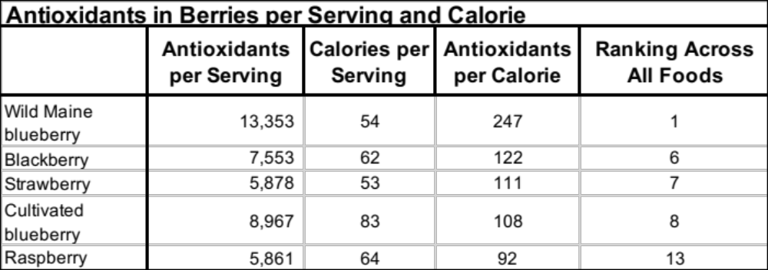

Check out those wild, low-bush Maine blueberries – hands down, the antioxidant rockstar of the realm.

The typical American diet delivers 3,000 to 5,000 total antioxidant units per day. Measurement methods are imperfect and opinions differ over how many units are needed for optimal health. But almost everyone agrees that average intakes in America are far too low, and increasing intakes will improve public health outcomes.

Optimal health likely requires at least 10,000 antioxidant units per day, ideally split between morning and later in the day. At such an optimal level of intake, the average calorie in a person’s daily diet would need to supply at least 5 antioxidant units (10,000 antioxidant units divided by 2,000 calories).

Take note that berries supply 20-times more antioxidants per calorie than the average food needs to. This is why they are universally regarded as super foods!

Consumption Regrettably, the average American consumes only about one-tenth of a serving of fresh berries on a daily basis. Strawberries account for about one-half of average daily berry intake. Total berry consumption needs to increase at least 5-fold to MAHA.

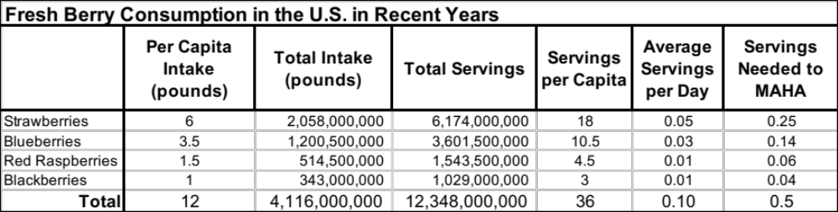

Processed berry consumption adds about another 0.03 serving to daily intake – about one-third of fresh consumption. It also needs to increase at least 5-fold.

Production Capacity There have been about 200,000 acres of berries harvested in the U.S. in recent years. The health-promoting nutrients produced from the harvesting of an average 20,000 pounds of berries from each acre are off the charts.

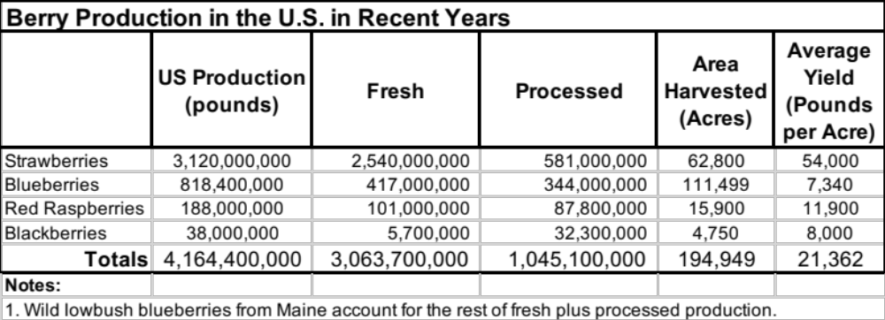

To meet demand for berries to promote public health in America, annual production will need to increase by ~800,000 acres, to a total of about 1 million. Today in the U.S., close to 60 million acres are devoted annually to biofuel production.

Good news -- Access to highly productive cropland is not going to be a constraint in growing supply to match demand.

Pesticides What about pesticides in berries? There is good news, but challenges remain.

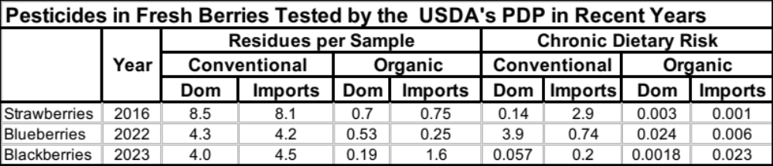

Good news –
- Chronic dietary risks are 20-X lower in domestic versus imported conventional strawberries, and over 3-X lower in blackberries.
- Just a few pesticides account for most of the risk in conventional berries, and each is expendable, or already illegal.
- Over one-third of the residues in organic blueberries and blackberries are spinosad, a biopesticide allowed for use on organic farms.
- About two-thirds of residues in organic berries are inadvertent (very low-level residues likely from drift, carryover in soil, irrigation water, processing plants), and very few exceed the NOP threshold (>5% of the applicable tolerance).

Organic berry farmers are unequivocally delivering on their promise to dramatically reduce pesticide dietary risk. “Experts” who argue otherwise are all spin and no science.

Bad news –
- Conventional strawberry samples contain, on average, over 8 pesticide residues.
- Imported conventional strawberries pose unacceptably high dietary risks.
- Dietary risks in conventional blueberries are very high because of residues of phosmet (an old OP insecticide).
- Residues of high-risk insecticides continue to account for most of the riskiest samples of fruits and vegetables. Where is bioIPM where we need it so badly?

Overall in 2025, organic produce accounted for 13% of total produce sales and 8% of volume. Market share is increasing, but not nearly fast enough to MAHA.

Organic berries grew by 12% in 2025. Total berry category sales topped the list of organic produce items, reaching $2.4 billion. Packaged salads were #2, with $1.4 billion in sales. Organic berries are already big business.

How can we grow organic berry sales to at least 80% of the market?

Easy answer – Give the American public the facts about how dramatically families can reduce their pesticide dietary risks by choosing organic, plus get more nutrients per calorie, and plus, get the flavor cherry on top.

The issue on our table today is what can Driscoll do to reduce pesticide dietary risks, and more rapidly grow the organic market.

The King of Berry Mountain

Driscoll over the years has done a lot of good:
- Much improved varieties.
- Cooperation in important research, like the organic versus conventional strawberry study led by John Reganold and published in PLOS One in 2010 that focused on nutrient density, soil health, and flavor. Several Driscoll growers participated in the study. Important findings included that the organic strawberries were more nutrient dense and more flavorful, and grew in markedly healthier soils.
- Creating opportunities for new growers to start their own operations.
- Expanding the year-round supply of fresh berries, including their organic brands.
- Investing in organic farming system innovation and supporting growers wanting to transition.

But Driscoll has also done things that have set back growth in the organic berry and produce business. It provided the political and economic muscle needed to gain National Organic Program approval of no-soil hydroponic systems, and found a way to do so despite widespread opposition from most of the pioneer growers and industry leaders who understood that organic farms can thrive only if they build and sustain healthy soil.

This remains Driscoll’s original sin, and one that still cuts deep, divides our community, and must not be allowed to fester much longer.

Today, with the flood of organic hydro berries from Peru, Chile, and Mexico, Driscoll has already, or is on the cusp of putting out of business many experienced organic berry growers.

It is simple. It is foundational to what organic farming has to offer. Hydroponics undermines that which makes organic special, and worth a premium price.

Because of Driscoll’s lock on so many major retail channels, the organic berry farmers that survive in the US will mostly do so by creating their own local or regional supply chains. But this task imposes on farmers new demands for their time, energy, and capital. It tends to keep them from expanding their operations, or mentoring others eager to jump in the organic berry pool.

As Driscoll has grown and become more profitable, the company has gained market power and influence, and deployed both in successful efforts to crowd out competition.

Unfortunately, when companies get as dominant as Driscoll, the need to keep growing and meeting profit expectations drives the train. The admirable goals and values that Driscoll personified in its first decades could soon slip out of sight.

We are talking about Driscoll on this beautiful fall day in the Hudson Valley because many of us sense Driscoll may be approaching a crossroads. The company is now the undisputed king of berry mountain. It seems though that the company is struggling with how to rule across its ever-expanding realm.

Low-Hanging Fruit

Many of us hope Driscoll will rediscover the reasons that fueled its growth and success. We hope Driscoll will use its economic and political clout as a force for the public good. There are three ways the company can do so, and in the process, recover the halo it has enjoyed for most of its history.

- Work with the organic community and NOP to heal the hydro-in-organic wound. The way to do so has been clear for many years – an hydro-grown organic label.
Why? Because we have all learned through bitter experience that it is harder to draw new people into the organic tent when the house is divided.

- Starting in California, Driscoll should transition all its production fields near schools and playgrounds to organic systems, or at least conventional systems that prohibit use of any dangerous synthetic pesticide, including fumigants.
As Driscoll figures out how to create disease-suppressive soils in CA, it can take lessons learned on the road, and then keep on truckin’ east until it runs out of road. Turning Florida berry production to mostly organic would be something truly worth celebrating!

- Stop using its size and resources to sideline or silence those that call upon it to do a better job for the its workers and their communities, the soil, our climate, the berry industry, and everyone’s health.

The heat rises in the kitchen of rapidly growing companies that thrive at the expense of others. Driscoll now finds itself embroiled in multiple lawsuits, vulnerable on multiple fronts, and maybe a little worried about the AC.

I have worked as an expert witness in dozens of cases against big, dominant food companies. They have plenty of money and access to legal talent, but they can also be tone deaf and arrogant.

Too many dominant companies choose to fight because they can, because they feel they need to project strength, and they can afford to lose.

They win some and lose some, but most consistently miss opportunities to find and implement solutions outside the courtroom where incremental, positive steps will deliver far greater ROI than slugging it out in a court of law.

In the break out session, I will share some details about a lawsuit Driscoll has filed against a small startup in Texas called Localize, “America’s [online] local farm marketplace” < https://www.localizefood.com/>.

The Localize team uses social media to grow its subscription base, and educate its users on how to find healthier food. Several months ago, some Localize posts drew attention to the campaign in California focused on pesticides, cancer, and Driscoll berry production. Some nasty and threatening comments directed at Driscoll were posted online by viewers. So the company sued Localize.

Imagine if every off-the-wall comment on social media were to wind up in court. Talk about the wheels of justice grinding to a halt.

Next week I will testify in a court hearing on behalf of Localize in opposition to Driscoll’s request for summary judgement (a motion asking the judge to order the relief sought by Driscoll immediately, before a trial).

I was asked by the attorney working for Localize to address whether there are any legitimate issues in Salinas-Watsonville over Driscoll berry production and cancer in kids. In my July 31, 2026 declaration, I explained to the court why I thought there were unresolved matters of fact, like what pesticides are being used on Driscoll production fields near schools. A copy of my declaration can be downloaded from the U.S. District Court, Northern District of California (Case No. 3:26-cv-05568-CRB), or access it from me or the Real Organic Project.

Getting back to berries. Eating much more of these super foods is absolutely essential to Make America Healthy Again, and especially for pregnant women and children.

We need to at least triple fruit and vegetable production, and hopefully, do so mostly in the US, where we can more assuredly take care of food-safety business.

And why not adopt whatever public policies are needed to assure that most of the growth in fruit and vegetable production happens on organic farms in the U.S. dedicated to, and supported in, their quest to enhance soil health and public health.

This critical “why not” question might be a good one to raise later this afternoon when the Congresspeople grace this stage. Thanks for this chance to talk berries with you.

